# IN712 JavaScript Canvas Practical

1. Write a JavaScript function that draws two rectangles that intersect like the figure shows, one of the rectangles needs to have alpha transparency.

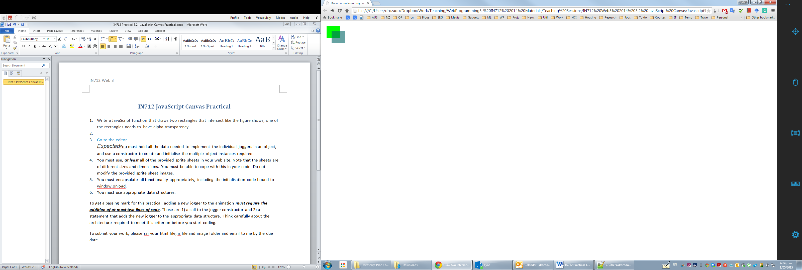

1. Write a JavaScript function that draws a smiley face like the figure shows.

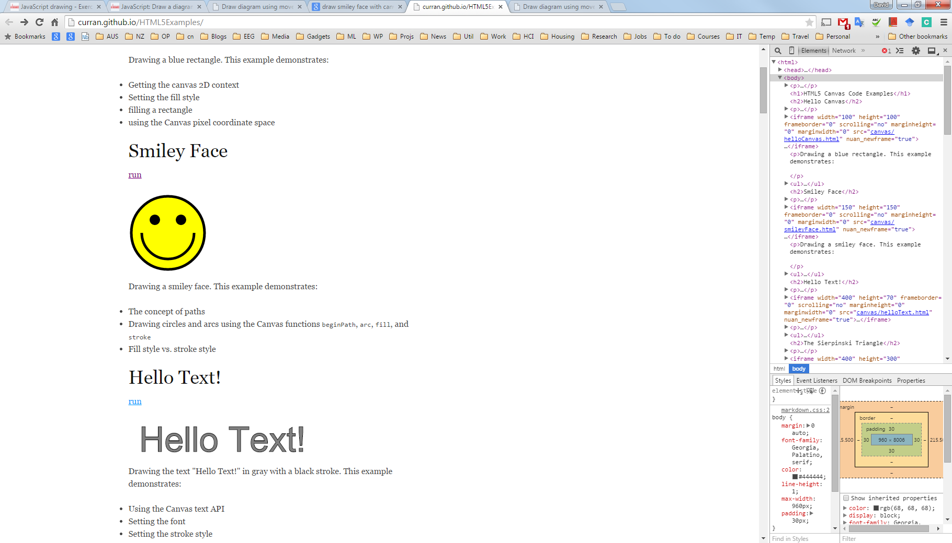

3. Create an animation of the earth circling around the sun

